Table of Contents

1 Prerequisites 2

2 Installation 2

3 Connect to crm 2

3.1 Instructions 2

4 Update Excel Export Limit 4

5 Export Customisations 5

6 Import Customisations 6

6.1 Excel Template 7

6.1.1 Entities 7

6.1.2 Fields 7

6.1.3 Relationships 8

6.1.4 Option Sets 8

6.1.5 Views 9

6.1.6 Execute Import 9

7 CRM record Report 12

7.1 Outline 12

7.2 Instructions 12

7.3 Settings 14

8 CRM Record Text search 15

8.1 Outline 15

8.2 Instructions 16

8.3 Settings 17

9 Data Import / Export 18

9.1 Import CSVs 18

9.2 Export XML 18

9.3 Import XML 19

10 Generate Code 19

# Prerequisites

The following prerequisites are required to be installed on the machine for the Myriad Xrm Developer Tool to install and run correctly. Administrator privileges are also required when executing the installer

* .NET Framework 4.5
* Windows Identity Foundation

# Installation

Run Myriad.Xrm.DeveloperTool.msi

# Connect to crm

## Instructions

* Select ‘connect to crm’ from the settings dropdown menu

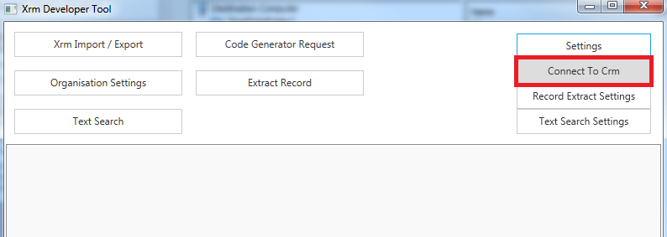

* Enter the authentication provider type*, details for the crm instance* and credentials of the crm user

*if the crm instance is ifd specify federation

*how to access the discovery service address and organization unique name is shown in a subsequent screenshot

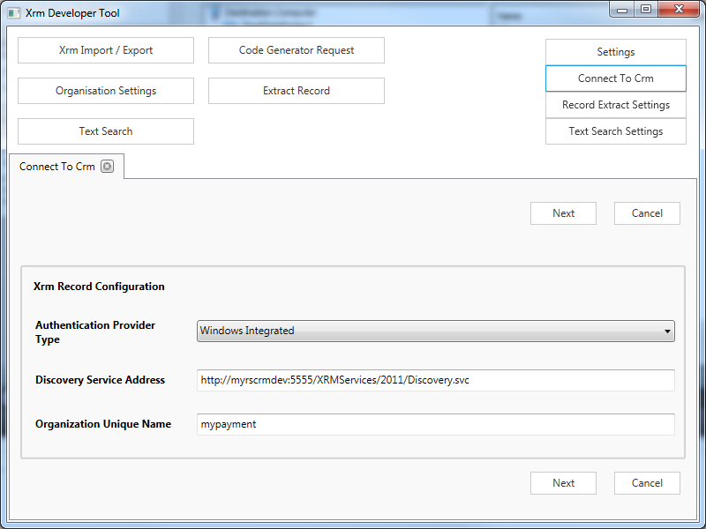

The discovery service address and organization unique name are accessible in crm by navigating to settings -> customizations -> developer resources

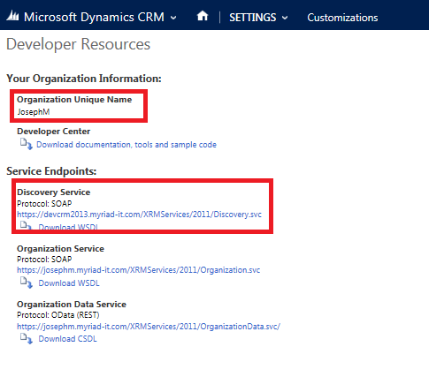

# Update Excel Export Limit

By default CRM limits the number of records exported from the system into excel to 10,000 records. This feature allows increasing that limit where more than 10,000 records are required to be exported

To update the limit for an excel export click ‘Update Excel Export Limit’ from the main menu

In the form modify the value and click save

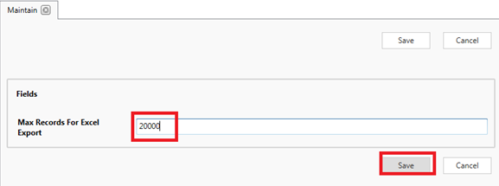

The limit will now be set to the new value you entered

# Export Customisations

This feature exports CRM customisations including schema names, labels, types and picklist keys into csv files. There are options to export

* Entity types
* Fields
* Option Sets
* Many to Many relationships

To run an export select ‘Export Customisations’ from the main menu

You may then

* Select the folder to output the csv files into
* Select which types of customisations to export by selecting their relevant checkbox
* Either Select ‘All Record Types’ or export only customisations for specific record types by adding and selecting them in the record types grid

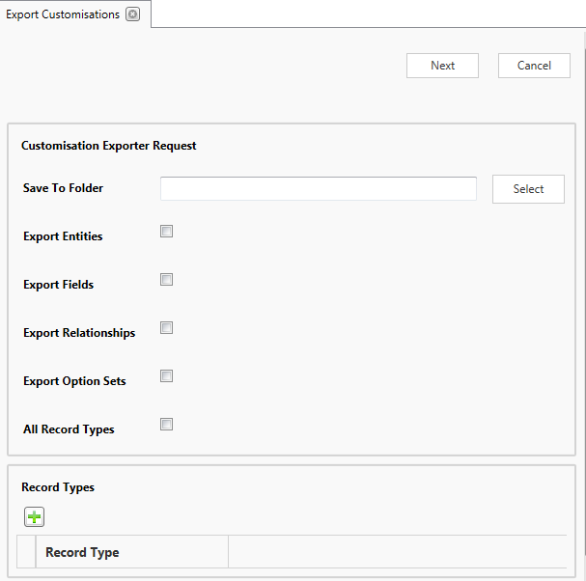

Once the above are complete click ‘Next’ for the csv files to be generated. Progress will be shown and once complete links to the files will be presented

# Import Customisations

This feature is designd to improve the creation and updating customisations in crm

Entities, fields, many to many relationships, option sets and some system views may be entered into an excel spreadsheet and uploaded into crm in bulk

## Excel Template

The Excel template contains 4 tabs for customisation components. View customisations are included in the fields tab

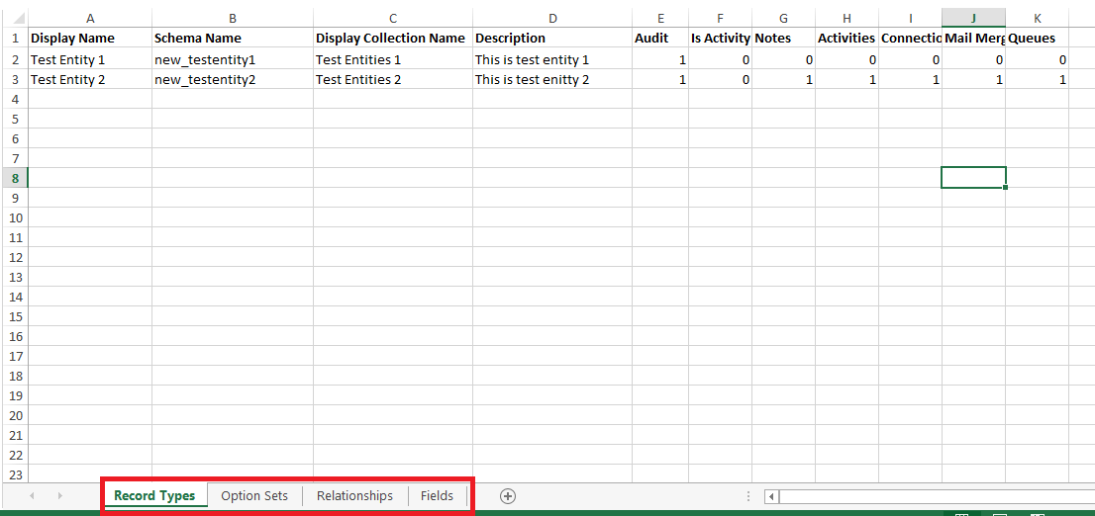

### Entities

Entity customisations are defined on the ‘Record Types’ tab. Note all Schema Names should use lower case

If you are creating a new entity then it is required to add a string field for that entity to the ‘Fields’ tab with ‘Is Primary Field’ set to true

### Fields

Fields are defined in the ‘Fields’ tab. Note all Schema Names should use lower case

The ‘Record Type Schema Name’ with the record type for that field

Some fields are or aren’t required depending on the type of field. For example Max Length will need to be populated for a string type field and Minimum and Maximum will need to be populated for an Integer or Decimal type field

Picklist options can be defined for a Picklist field by referencing the name of an Option Set in the ‘Option Sets’ tab

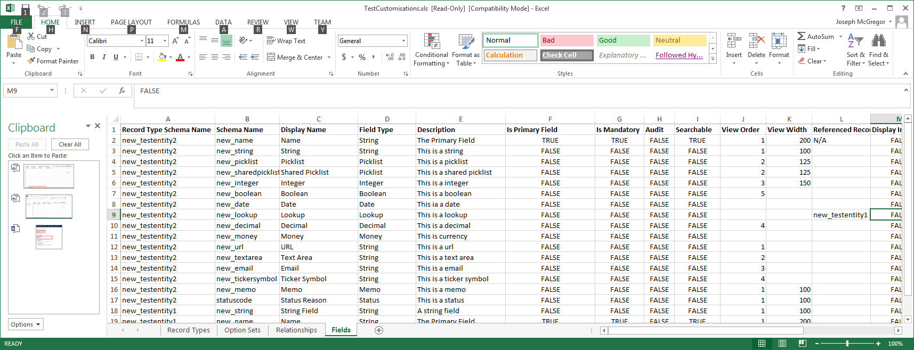

### Relationships

N to N Relationships may be defined in the ‘Relationships’ tab. This just imports/updates N to N relationships between entities. Always use lower case for schema names

### Option Sets

Field specific or shared option sets may be imported from the ‘Option Sets’ tab. Always use lower case for schema names

Option Set Name is required to be referenced from the Picklist Options column of the ‘Fields’ tab if they are to be set for a particular field

Note if a field label is a number then it is required to prefix it with ‘TXT_’ so the Excel file does not read the column as numbers. E.g. for a label of ‘60’ set it as ‘TXT_60’

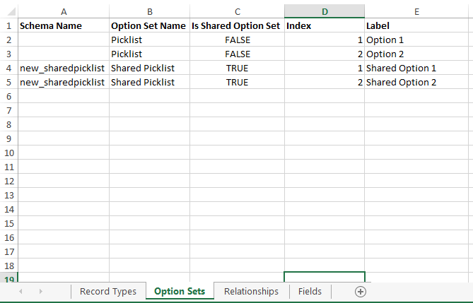

### Views

Views are defined in the ‘Fields’ tab. The application will update a set of system views for an entity type as defined. Sort By And Filters cannot be defined in the spreadsheet

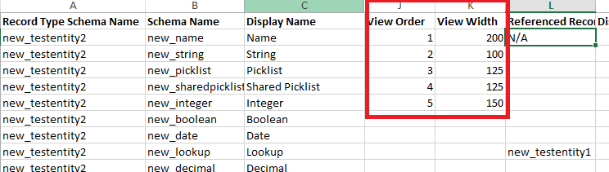

### Execute Import

To Execute the import select the ‘Customisation Import’ button from the top of the screen

You then need to select the MS Excel file containing the customisations to import and check the specific component types to import

You may elect to only import/update the fields and/or entities or any other combination of the component types

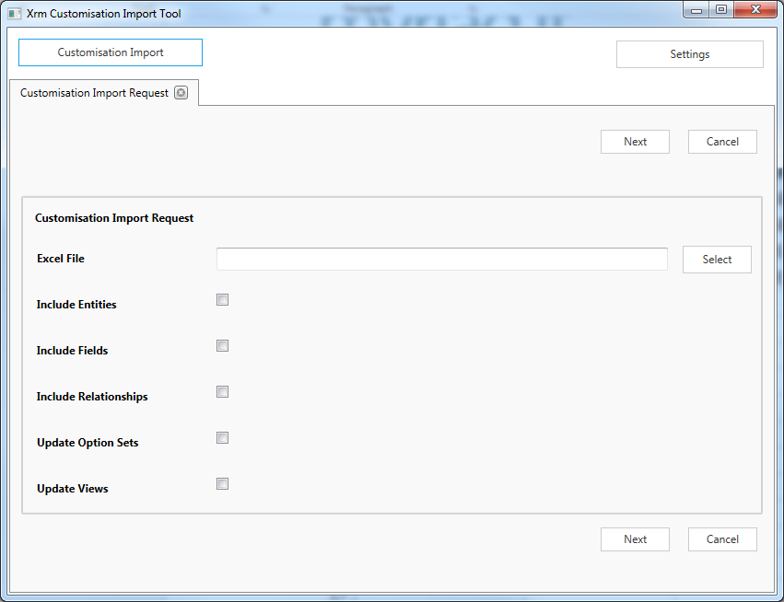

When ‘Next is click the system will then proceed to execute the import

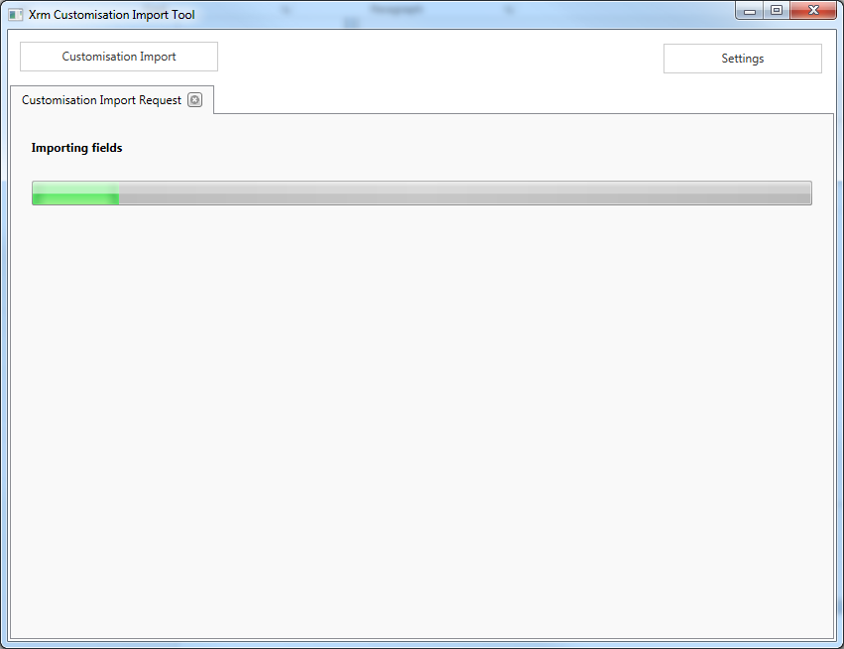

Then display a details of the imported items including any errors

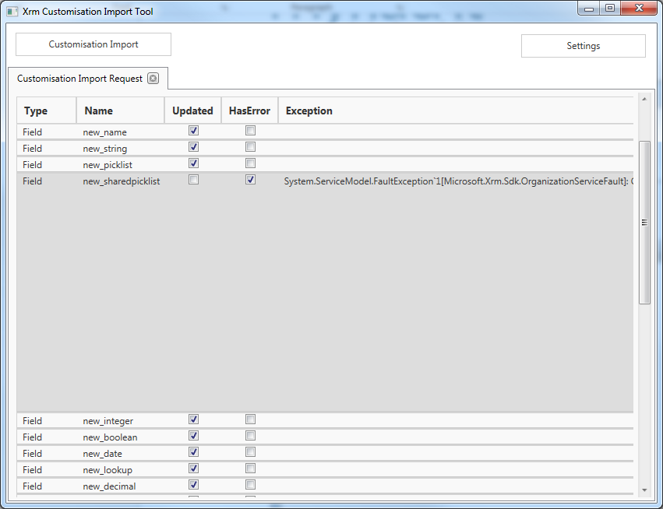

# CRM record Report

## Outline

The extract record function can be used to export all fields for a record as well as detail of all related records

## Instructions

* Click the CRM Record Report option from the main menu
* Enter the save to folder, document format and record type
* Search and select a record of the selected type by entering its name (or any number of the starting characters), searching then selecting it from the search match dropdown

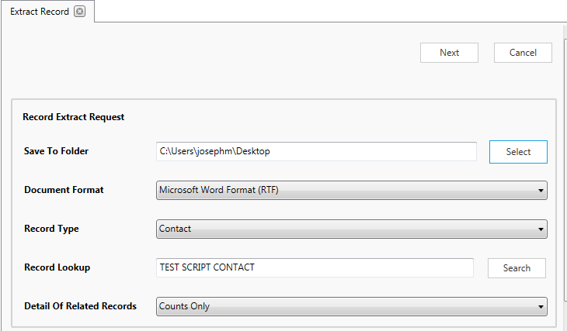

* Click next
* Wait for the system to search and generate the document

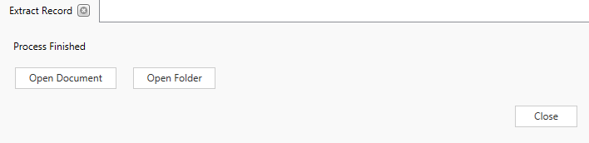

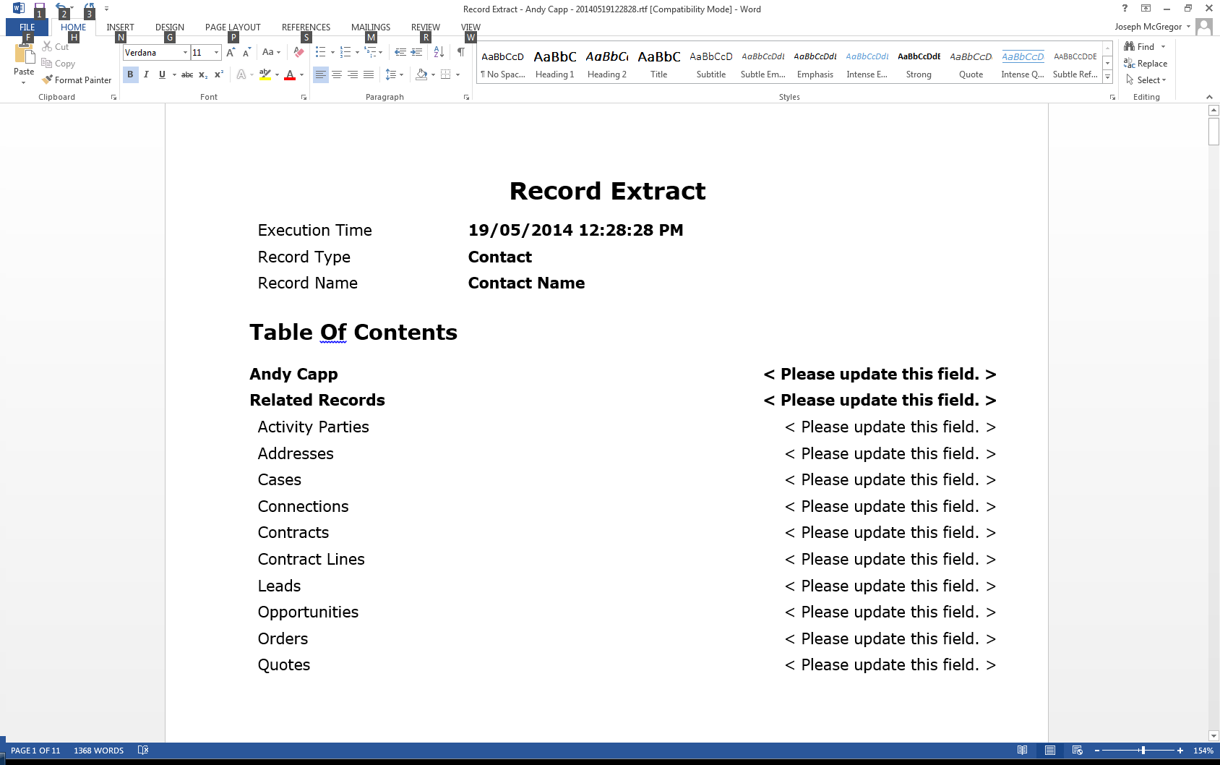

## Settings

There are several settings for the record extract which can be configured by selecting “Record Report Settings” from the settings dropdown

These give the ability to

1. Include or exclude several system fields from the export
2. Limit the types of records which can be selected for export
3. Exclude specific record types from the record types which are output as linked record
4. Specify to only display the name for linked records of a particular type rather than detailing all the fields in the record

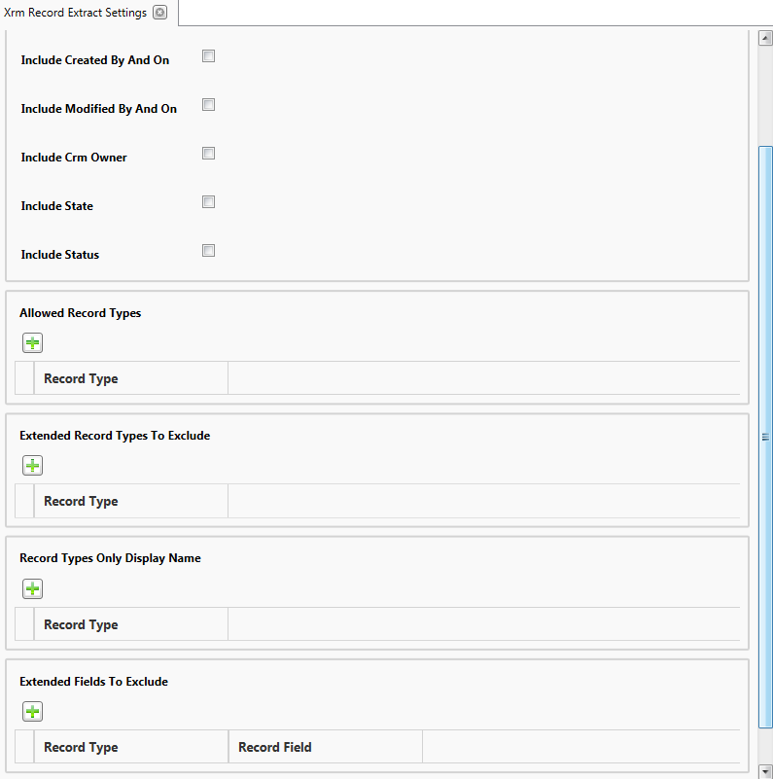

# CRM Record Text search

## Outline

The text search function will search all text fields in crm for containing the search text

The generated document will

1. Detail all record names and fields which contain the text
2. Append a record extract for any records with a matching name

Note the text search function uses the crm web services (which are not designed for this level of text searching) rather than custom indexed databases and will take a progressively longer amount of time for larger volumes of records

## Instructions

* Click the “CRM Record Text Search” option from the main menu
* Enter the save to folder, document format and search text then click next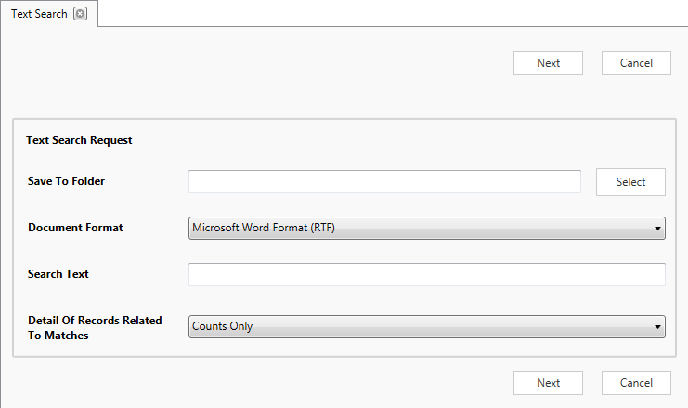
* Wait for the system to search through the text fields and generate a document outlining any matches in the system

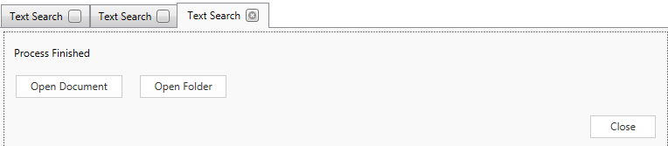

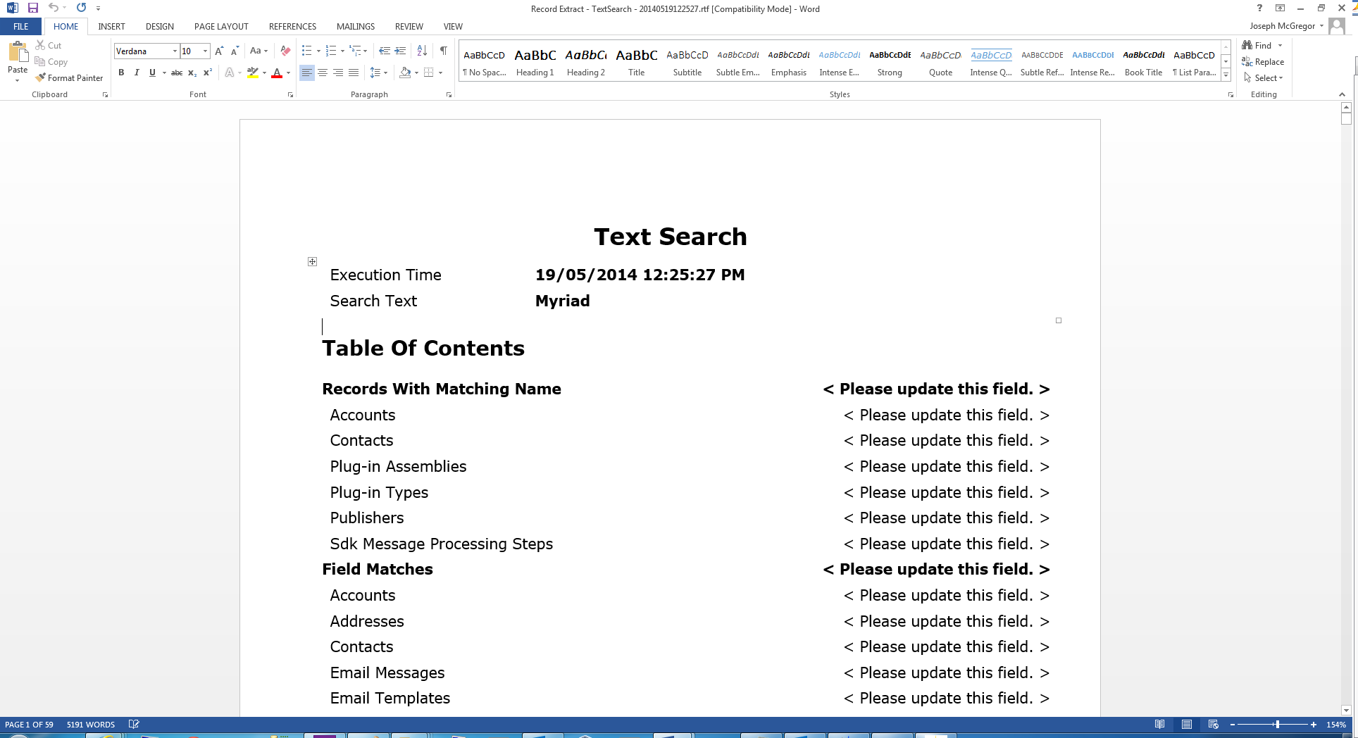

## Settings

There are several settings for the text search which can be configured by selecting “Text Search Settings” from the settings dropdown

These give the ability to

1. Configure the number of record per search set*
2. Exclude specific record types from the search
3. Exclude specific fields from the search
4. Set a field to search in sets*. This should be used if the application reports timeout errors when searching a text field

*the search sets were implemented for fields with a large volume of text. As the crm supported database access and web service does not allow indexing of full-text indexing of text fields where there is a large volume of text the application must iteratively search sets of records at a time so the web service/sql server does not timeout when searching through an excessive amount of text. An example of this is email content or note text which are configured by the system to always search in sets of records

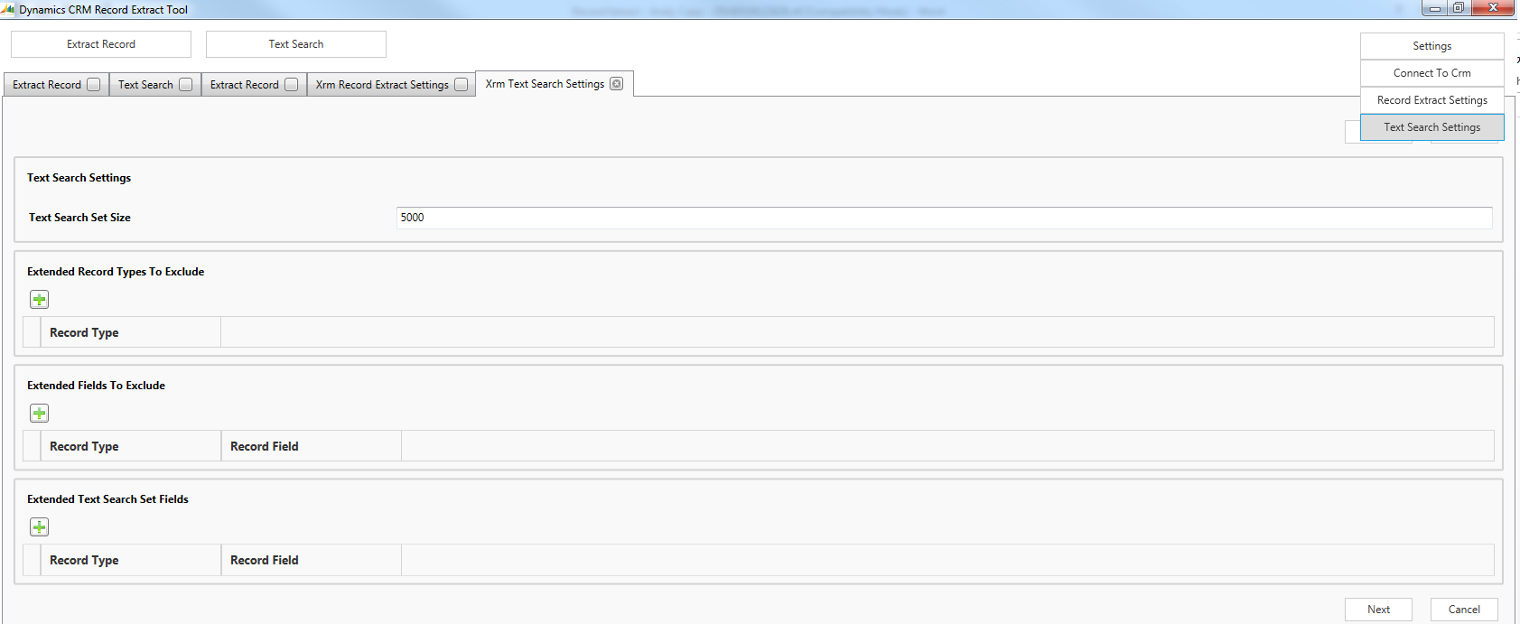

# Data Import / Export

These features are designed for simplifying bulk data imports and migrating data between environments

## Import CSVs

This feature allows the user to select a folder to import multiple csv files of data to the target environment

* The user may select top match records by Name in which case if the record is matched it will update the record which matches its name, if there is no match (or Match By Name) was not selected new records will be created
* Each CSV file should be name according the target types label or collection name
* Each column in a CSV should have a heading with the label of the target field in that column
* Note the import allows the user to specify either American (mm/dd/yyyy) or English (dd/mm/yyyy) format dates as when data exported from crm and saved as a csv by default I found it saved the dates in US format

## Export XML

This feature is designed to be used in combination with the Import XML feature. The user may select multiple record types and the application will export all records of the type/s into xml files

The Import XML feature may then be used to migrate those records to a different environment

## Import XML

This feature is designed to be used in combination with the Export XML feature

The user may select a folder containing xml files of exported records and the application will import them into a target environment

If the record already exists in the target environment (matching by primary key) it will be updated, otherwise a new record will be created

# Generate Code

This feature is for generating code constants for CRM customisations

Options are

* C# Constants for CRM entity and field names
* C# Constants for picklist values
* Javascript Constants for picklist values